
Vrinda Store
ANNUAL repoat
2022
Annual Report
2022

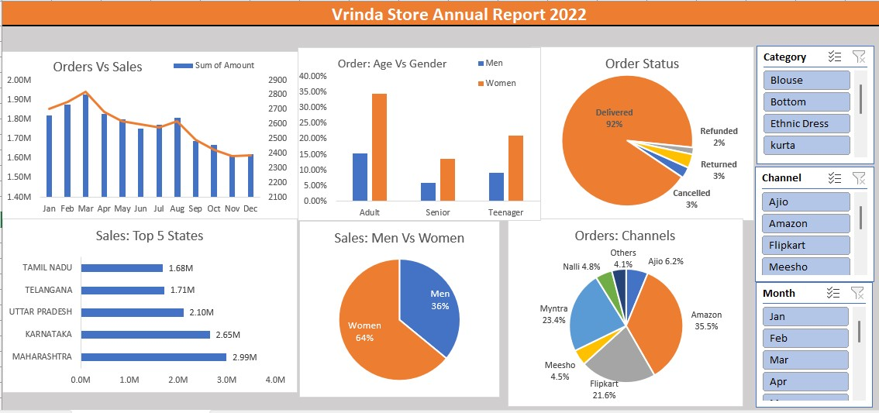

Key Insights
❑Women are more likely to buy compared to men (~65%)
❑Maharashtra, Karnataka and Uttar Pradesh are the top 3 states (~35%)
❑Adult age group (30-49 yrs) is max contributing (~50%)
❑Amazon, Flipkart and Myntra channels are max contributing (~80%)
Final Conclusion to improve Vrinda store sales:
❑ Target women customers of age group (30-49 yrs) living in Maharashtra, Karnataka and Uttar Pradesh by showing ads/offers/coupons available on Amazon, Flipkart and Myntra

